**Information about “LAST LAND”**

It is information that will be useful to you.

**About layers**

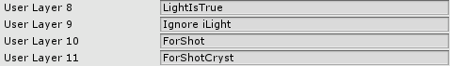

“User Layer 8” - This layer contains all objects which must be lighted in real time.

“User Layer 9” - This layer contains objects which mustn`t be lighted in real time.

“User Layer 10” - This layer contains objects that can be push away by explosion.

“User Layer 11” - This layer contains crystals.

Additionally: Some scripts use the names of the layers.

**About tags**

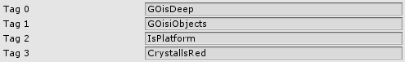

“Tag 0” – It`s the tag that contains abysses. (Triggers are the pits. The player loses when entering in them.)

“Tag 1” – It`s the tag that contains walls. (Triggers are the walls. The player loses when entering in them.)

“Tag 2” – It`s the tag that contains platforms that move. (Triggers are on the platforms. The platforms stop when player enters in them.)

“Tag 3” – It`s the tag that contains objects which cause a red wave. (For example it`s in Place 20.)

Additionally: Some scripts use the names of the tags.

**Build Settings**

The first scene is the "ViewStart", second is “Place Menu”. The other scenes don't have important sequence.

**Where I can to put my music? (In Game)**

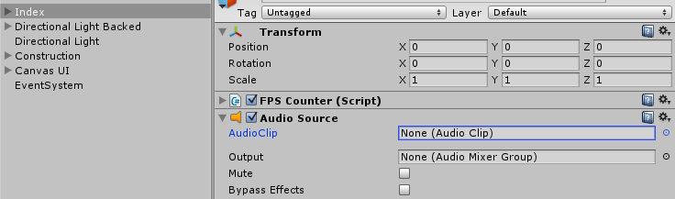

You can to put your music in this Audio Source. Other scenes have a similar analogy.

**Where I can to put my music? (In Menu)**

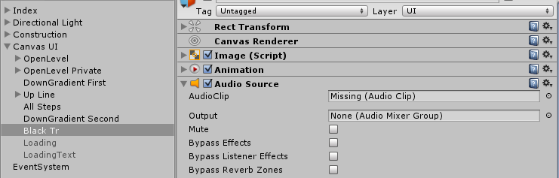

You can to put your music in this Audio Source.

**Information that important**

1) Almost all scripts find objects by name. Do not rename any objects if it`s not needed.

2) Music removed, in order not to violate the law. You can always purchase your music anywhere.

3) All sounds were taken from freesound.org license "cc0 1.0 universal (cc0 1.0) In The Public Domain"

**Can I publish this game in Google Play?**

The game is sold as a template. This means that you aren`t able to publish it in its original form. You can safely change it as you wish, and publish.

**About scripts**

**Scripts/ Gameplay/ For Other/ BlackMode.cs**

You probably noticed that in some levels there is a sharp change of materials. This script is responsible for this action. It is located on the objects with the name "BlackMode".

Parameters:

Sound Of True - sound when the player enters a trigger;

Objects For Material - objects which are assigned new material from the variable Set Material;

Different Obj - objects which are assigned new material from the array with name “Different Material”;

True Obj and False Obj - objects that are enabled and disabled when the player enters in trigger;

**Scripts/ Gameplay/ For Other/ CollSound.cs**

When you click on cubes, they collide with other objects and make sounds. This script is responsible for the volume of the sounds. The volume of the sounds depends on the force of the collision.

Parameters:

Min Max Velocity - Vector2, where X is the minimum force of the collision (if less, then the sound is not heard), Y is the maximum force of the collision (maximum sound volume);

**Scripts/ Gameplay/ For Other/ ExplosionInTouch.cs**

This script is responsible for an explosion which occurs when you touch certain objects. It located on object with name - "Explosive Touch".

Parameters:

Explosion Force – force of explosion;

Multiplier - multiplier of force;

Use Flare - Flare in the explosion;

Random Rot - the value to use in the script. It calculated in script;

Explosions - the sound of the explosion;

**Scripts/ Gameplay/ For Other/ ForRope.cs**

This script is used to fade the ropes after pressing. Using in Place 10.

Parameters:

Save LR – Line Renderer which constructed;

**Scripts/ Gameplay/ For Other/ Place20.cs**

This script is designed to work at 15 and 30 levels.

**Scripts/ Gameplay/ For Other/ RedExplosion.cs**

This script is responsible for the red wave which appears when touching certain objects. For example it`s in Place 20.

Parameters:

Red Mesh – red plane which located in this scene;

Explosion Sound – play sound when red explosion is started;

**Scripts/ Gameplay/ For Other/ Rope.cs**

This script is responsible for working ropes in some levels. For example, Place 20.

Parameters:

Line Rope – Line Renderer which constructed by the objects in array with name “Array Point”;

**Scripts/ Gameplay/ For Other/ StepInMove.cs**

In some levels you may need what would the steps remain on the platforms that move. This script is designed to do it. For example it`s in Place 22. It located on object with name - "FootStep". As to the object you need to add a Trigger and Rigidbody.

**Scripts/ Gameplay/ For Other/ StepToPlatform.cs**

In some levels will come in handy to stop the platform when the player steps on them. This is the script designed for this purpose. Just put this script on the Player and in platform make a trigger with the tag "IsPlatform".

**Scripts/ Gameplay/ For Other/ TriggerActiv.cs**

In some scenes you may need to throw boxes at the course in the trigger. This script is responsible for it. For example, Place 4. It located on object with name – "Trigger Starter".

Parameters:

Use Object – an object which will use;

Change Gravity - change the gravity to the value indicated;

Change Force - force which add to object when Player entering in trigger;

Change Torque - torque which add to object when Player entering in trigger;

**Scripts/ Gameplay/ ForPlayer.cs**

This script is on the player. He is responsible for a loss when the player enters a trigger.

Parameters:

Is Game Over – it`s variable for this script;

Effect To Go – it`s red image in UI that activate when player is lose;

To Game Over – it`s sound of game over;

**Scripts/ Gameplay/ ManAnimation.cs**

Perhaps you noticed that at the end of levels there is an animated image of the figure. This script is responsible for the animation of the image.

It is in the hierarchy: Construction/ Environment Mesh/ Man/

Parameters:

List Of Man – it`s images that change in material with speed – Time Change;

**Scripts/ Gameplay/ MoveCamera.cs**

It`s a main script that moves a camera and player.

Parameters:

Speed Of Player – Player moves with that speed;

I_Player – object of player;

Max Dist BS – this is the distance between steps;

Step – object of step;

Step Icon – icon of step which locate in upper left angle;

Height Of Cam – it`s a height of camera;

Dist Cam Z – it`s a distance between camera and player;

**Scripts/ Gameplay/ ShotCentre.cs**

This is the script which creates explosions when you click on different objects.

Parameters:

Shot Input Layer – layer where contain objects which can be push;

Shot Input Layer Add - layer where contain crystals;

Max Distance Of Shot – this is the maximum distance on which there are explosions;

Explosion In Touch – object of explosion;

Cube In Touch – object of cube which will be created when you click to crystals;

Container For Created – object where will be created explosions and cubes;

**Scripts/ Gameplay/ StepsSet.cs**

This is the script that creates animation effects of steps.

Parameters:

No Add Step – enabled if you don`t want add steps in record;

List Of Step – it`s images that create effect of animation steps;

**Scripts/ GameSettings/ Finish.cs**

It`s the script which responsible for finish and contain names of main scenes.

It`s located on object with name “Finish Panel” in hierarchy: Canvas UI/ Finish Panel/

Parameters:

Name Of S Next – name of next scene (level);

Name Of S Menu - name of scene (menu);

Name Of This Scene – name of this scene, but only last part of name (L + number of level);

**Scripts/ GameSettings/ Pause.cs**

This script located in hierarchy: Canvas UI/ Pause Panel.

It hasn`t got a main parameters.

**Scripts/ GameSettings/ Reset.cs**

This script located in hierarchy: Canvas UI/ Reset Panel.

It hasn`t got a main parameters.

**Scripts/ Menu/ MenuUI.cs**

This is the script which responsible for all actions in menu.

Thank you for your purchase :)

If you have some questions then please mail me.

andrew.olnk@gmail.com

My site: http://amazeplay.esy.es